1) Title of the project- ContactRed using Android Forensics.

**Project Proposal:-**

Mobile Forensics is the process of analysing and accessing the data from the Mobile devices using forensic tools and different memory acquisition methods so that the Passwords or Passcodes of the device are cracked and able get to the /data/data/ repositories. The Project “Contact Red” is a Red team activity.  
The proposals or ideas of the Project are as follows:  
First to crack the passcode or a way to get into a mobile system. Next getting access to the Phone MMS/SMS depository data and update the setting, to block a particular contact like Bank Customer care so that User is unable to see the transaction alerts provided by Bank.

Following are the tools to be used for Project implementation:   
ADB,SQLite commands,

Learning from:

1. Android Forensics and Security Testing, presentation By Shawn Valle
2. 2022_Book_MobileForensicsTheFileFormat, about F2F system
3. <https://android-doc.github.io/tools/help/adb.html> , about ADB and Adb commands
4. <https://www.youtube.com/watch?v=UmjDMuwIeAI> , ADB setup using Android studio

As part of the First Deliverable:

> Learnt about F2F system and ADB tool, setup

> Accessing the Device in which the ADB commands will be ran

> Documentation

Steps to run ADB tool:

1. Run Android Studio, under Device manger select Nexu 5X API 25 and install

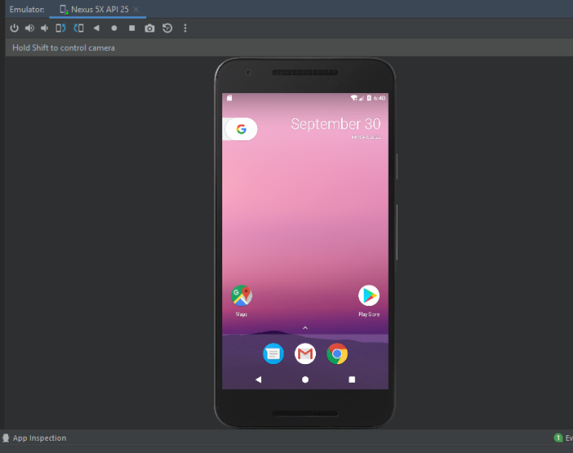

1. Copy “C:\Users\DELL\AppData\Local\Android\Sdk\platform-tools” into path of Environmental variables

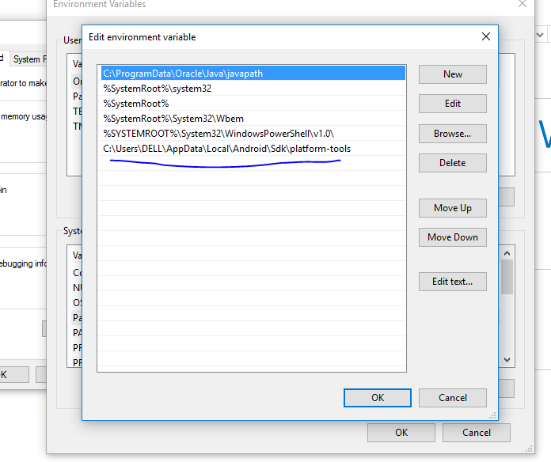

1. Open the terminal and start running below ADB commands to access Emulator

run

“C:\Users\DELL>adb”

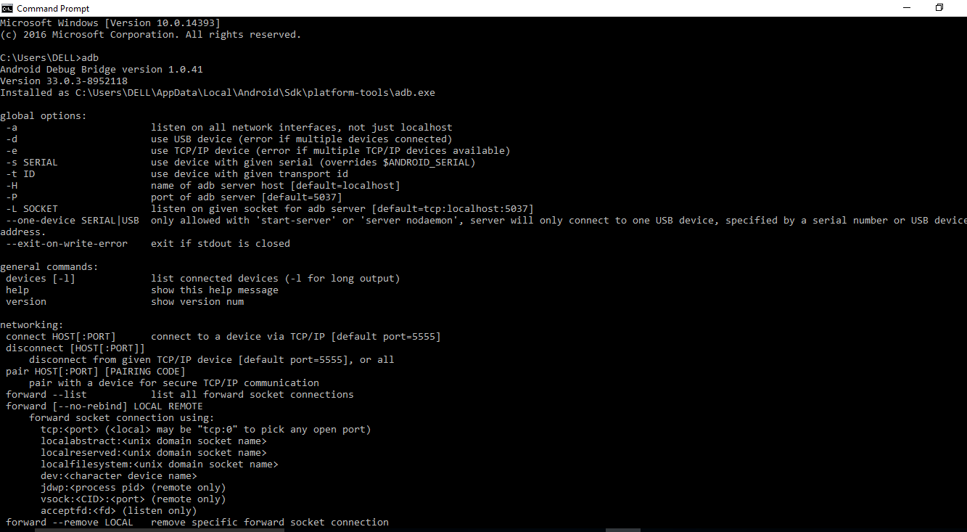

1. Will check for devices available to connect

(Currently we need to turn on Developer options if device is showing offline after running the below command)

Run “adb devices”

Run adb devices -l

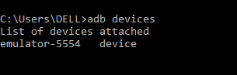



1. Inorder to view the Properties of the device

Run “adb shell getprop”

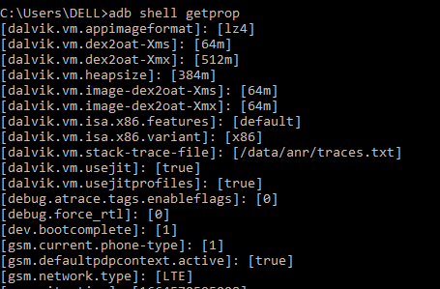

1. Inorder get into system

Run “ adb shell”

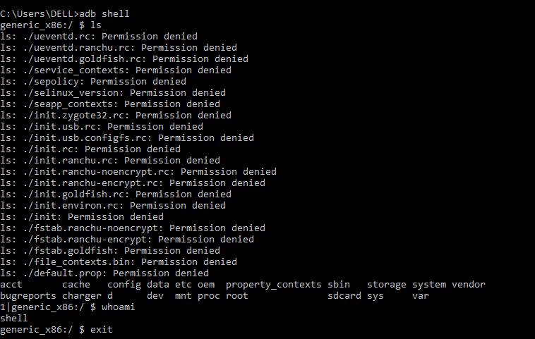

1. Next will get into sdcard of the device

Running

“cd sdcard/”

“ls”

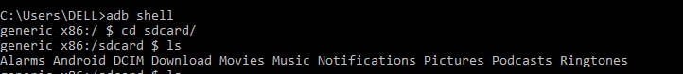

1. Creating a text file into sdcard with a text

>/sdcard $ touch temp.txt

> echo “text” > temp.txt

>cat temp.txt





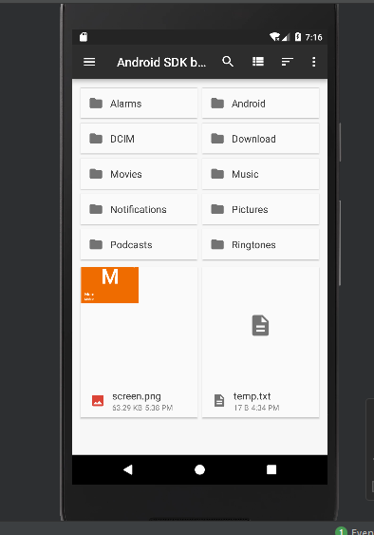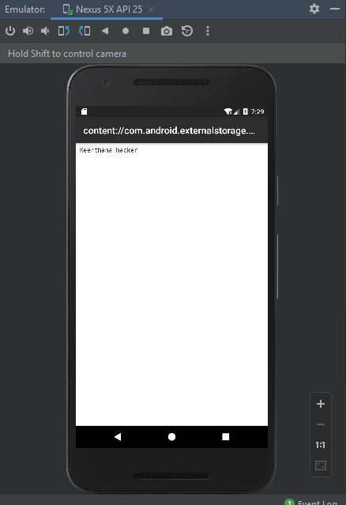

1. Taking screenshot of the device and pull from device

Run “ screencap /sdcard/screen.png”

Run “exit”

Run “adb pull /sdcard/screen.png”

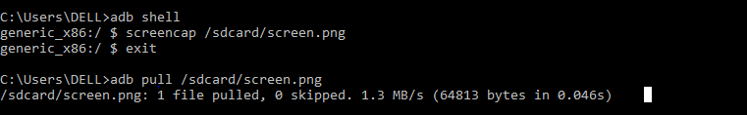

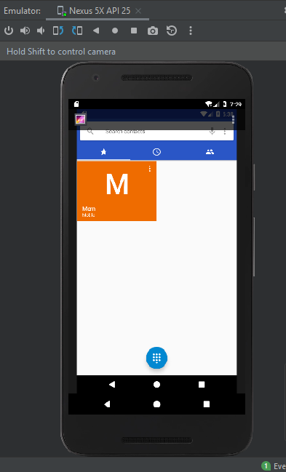

Contributions:

For the project, we have done the Exploring, Knowledge sharing, implementing and documenting processes about the tool and running part

>Each teammate had spent significant amount of efforts towards the above processes to learn and progress in the project

Next project Deliverables:

* To learn and explore more about the ADB tool and commands to run
* Knowing about the possible challenges to access the various storages of the devices
* Working towards the goal of the project to update the contact data